Scientific and Practical Conference on Petroleum Hydrogeology and Geochemistry "Practice GeoChemistry 2022"

Requirements for poster presentations

- General provisions
1.1 The possibility of presenting poster presentations at the conference "PRACTICE GEOCHEMISTRY 2022" (hereinafter - Conference) is realized with the aim of publishing the results of research. The author of the report should independently prepare a poster in PDF format in accordance with the requirements of Section 2 and send it to the organizers to practicegeochemistry@gmail.com not later than 13 July, 2022 (In the subject line of the letter, please add the name of selected area of your report (e.g. - "Metrology of geochemical research") and your full name).

Appearance and size of the stand
  - Poster size - 841x1189 mm (format A0), portrait orientation.
  - Text at the top of the poster:
- the title of the work, written in 48-point font (height of the capital letter 12 mm);
- right under the title - the surname, the name of the author and the scientific supervisor, the organization and the place where the work was done - font size 36 points (height of the capital letter 8 mm).
  - The text with the main information about the research (i.e. - goals and objectives, research methods, obtained results and conclusions) should be made in Times New Roman font, size not less than 22 points, 1.5 spacing. The text font should be freely readable from a distance of 1 m.
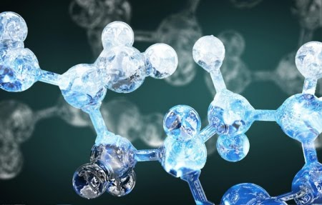
Figure 1 - a preparation example of the figure.

Table 1 - a preparation example of the table.

Sample table
Sample table

𝑄 = 𝑘 ∙ ∆𝑃 ∙ 𝐹, (1)
η 𝐿
Q — Volumetric flow rate (m³/s). (a preparation example of the formula)

Structure of the stand
  - Goals and objectives of the work.
3.2 What was done during the work.
  - Used methods.
  - Main results of the work.
  - Conclusions.
The stand should meet the following requirements:
Appearance. A cursory glance at the stand should give the viewer an idea of the topic and nature of the work.
The ratio of illustrative and textual material should be at least 1:1. Illustrative material such as photos, diagrams and graphs should have descriptions.
The optimal amount of information. The amount of information should let the viewer fully understand the stand in 1-2 minutes.
Focus and clarity. Complexity of the information in the text should enable the participants to understand what is being discussed. The speaker can give more complicated information at the stand.

Stand Session
  - The stand session is organized by the organizing committee in a specially allocated area.
The stand session is included in the program of the Conference events
4.3 Poster presentations have a specified timing according to the program of the Conference.
4.4 The solution of technical issues of the stand session is provided by the University, on the basis of which the Conference is held.
4.5 In the course of the stand session the participants of the Conference are provided with free access to the materials of the stand reports, the author (co-author) should be near the stand (personally or remotely).

5. Stand evaluation by experts
5.1 An expert committee from among the Jury members, established for the assessment of the section reports, shall be involved for the evaluation of the poster reports.
5.2 The Jury members assess the submitted papers according to the criteria of the in-person presentations of the Conference.
5.3 Poster reports are assessed in a separate nomination from the section papers.

We wish everybody good luck!

