An example of a thesis
Title of the Report

P.D Mallory, D.M. Nourozieh², Y.C. Chen²
1-KFU, Institute of Geology and Petroleum Technologies
2- Tatneft PJSC
Academic supervisor: Dr. Alex Jackson
E-mail: mallory@yandex.ru

Abstract
The pilot tests were initiated….

Key words
Simulation, …

This paragraph begins the main part of your thesis; you should give references to sources [1,2]. Also in the thesis may be figures, tables and formulas (figure 1). Numbering of figures, tables and formulas should be sequential, according to their presence in the text. Make sure that all figures and tables are cited in the text. A short caption is needed for each figure and table. Correctly form a reference to the table (Table 1). Correctly make references to the formula (1). Before you begin to write your thesis, carefully read the requirements for the thesis.
This is the beginning of the second paragraph of your thesis; use these paragraphs as an example of proper formatting.

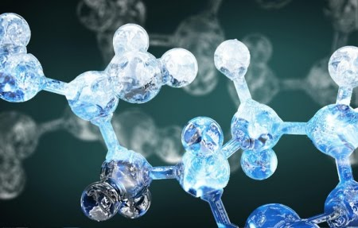

Figure 1 - a preparation example of the figure.

Table 1 - a preparation example of the table.

Sample table
Sample table

Extends Table 1 (if the table has moved to another page)

Sample table
Sample table

$Q= \frac{k}{η}∙\frac{∆P}{L}∙F,$ (1)
Q — Volumetric flow rate (m³/s). (a preparation example of the formula)

List of references
- Reference (reference is in the format APA)
- Reference
- …

